**15 SELECTED HANDS-ON LABS SCREENSHOT ON QWIKLABSPRESENTATION**

1. Implementing Cloud SQL workshop

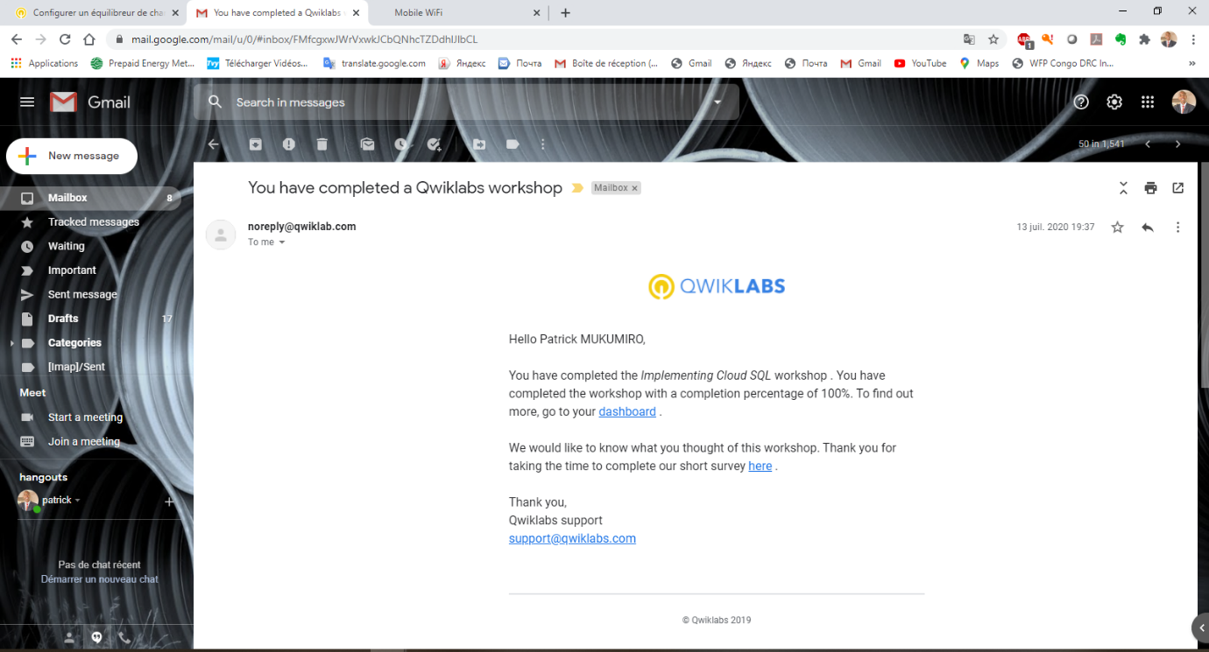

1. Examining Billing data with BigQuery workshop

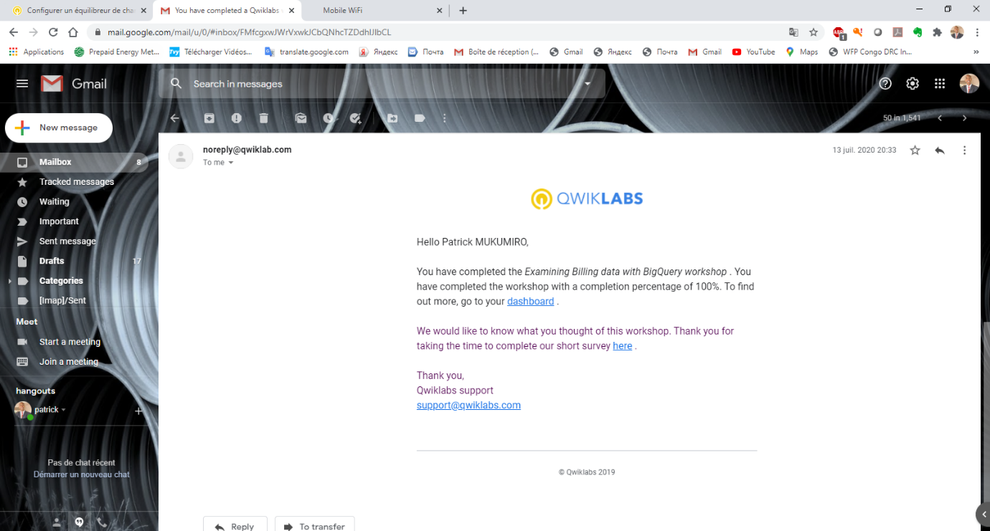

1. Resource Monitoring workshop

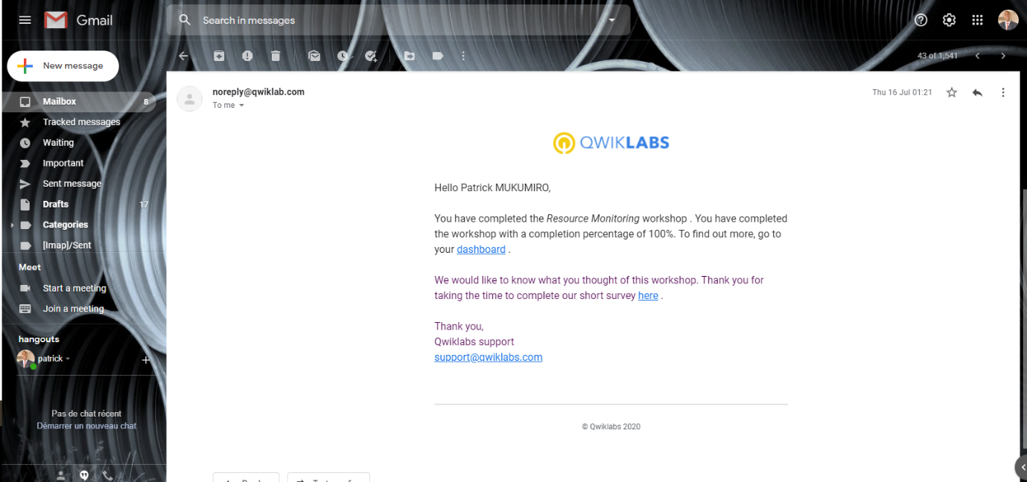

1. Error Reporting and Debugging workshop

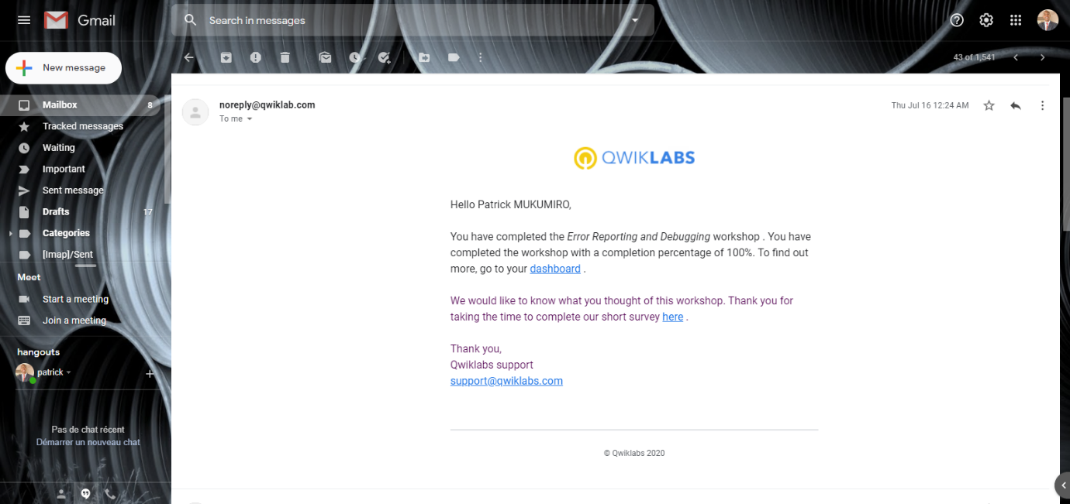

1. Continuous Deployment with Jenkins v1.6 workshop

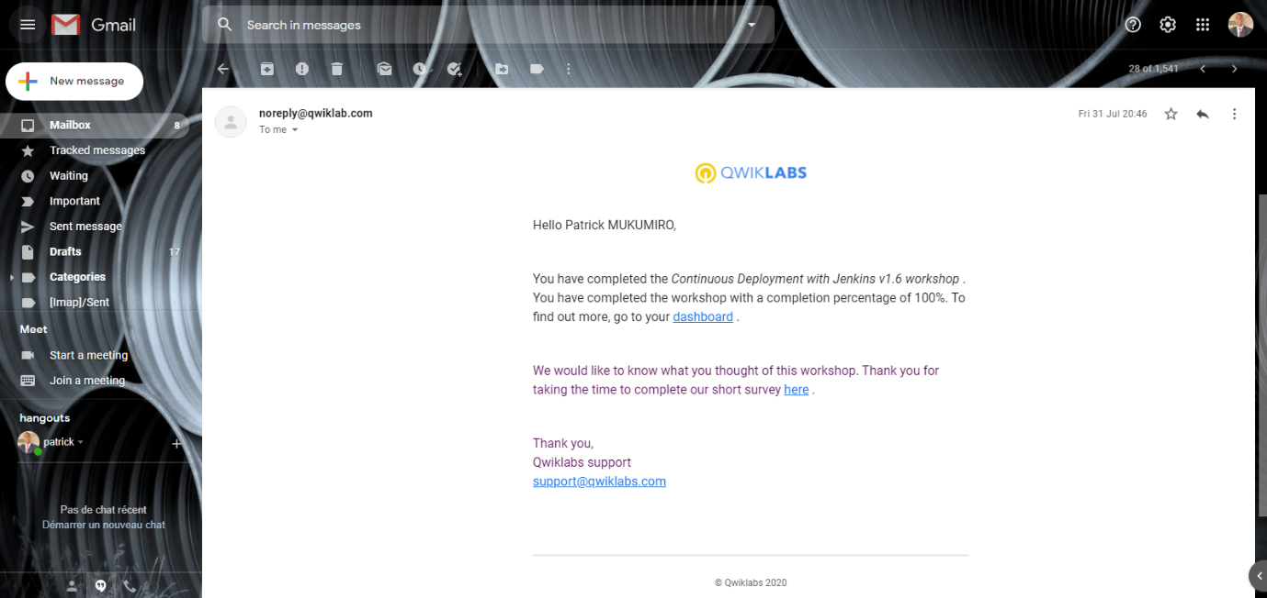

1. Deploying to Kubernetes v1.6 workshop

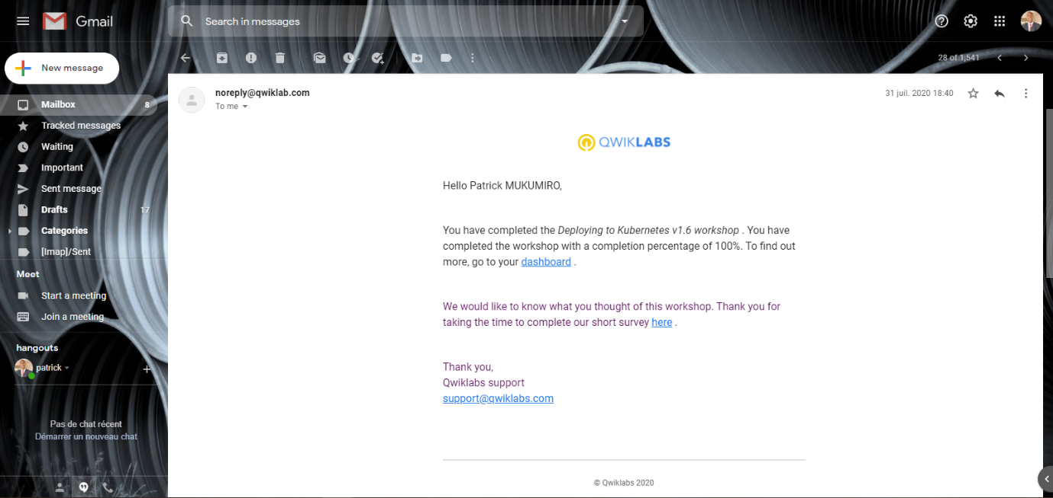

1. Kubernetes Basics v1.6 lab.

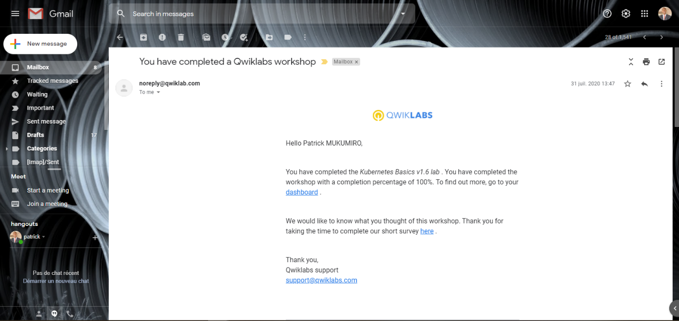

1. Working with Virtual Machines

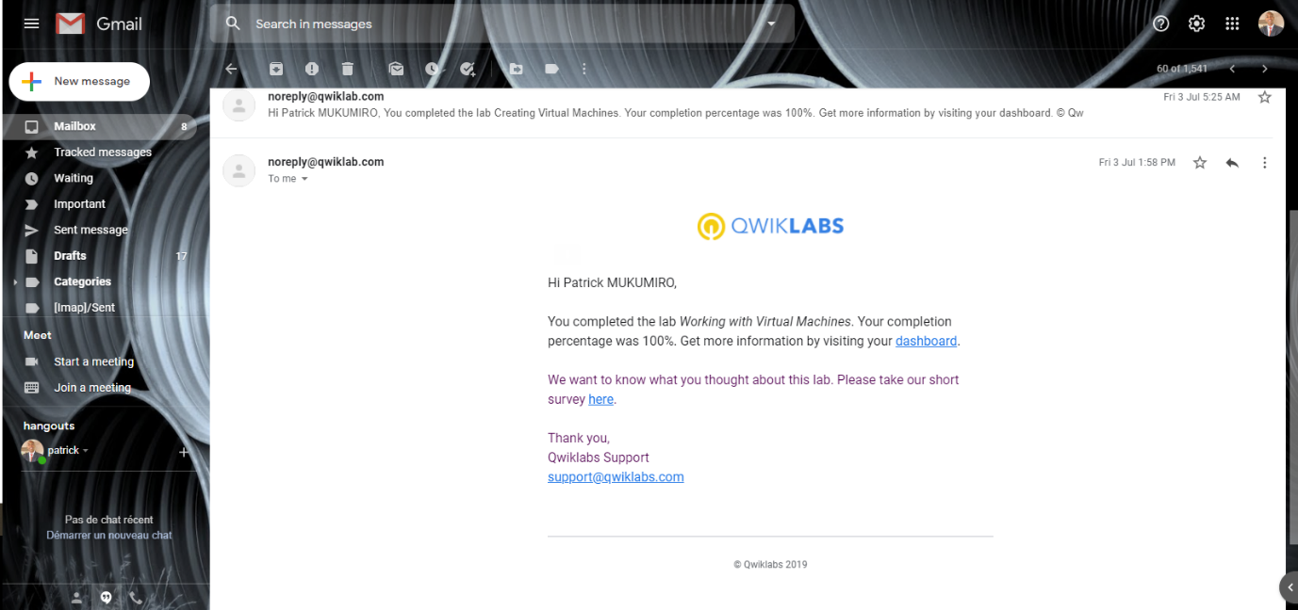

1. Creating Virtual Machines

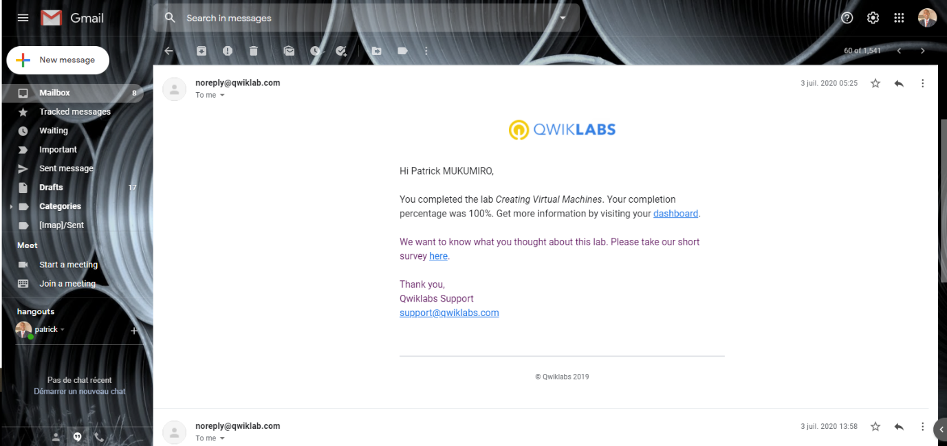

1. Implement Private Google Access and Cloud NAT

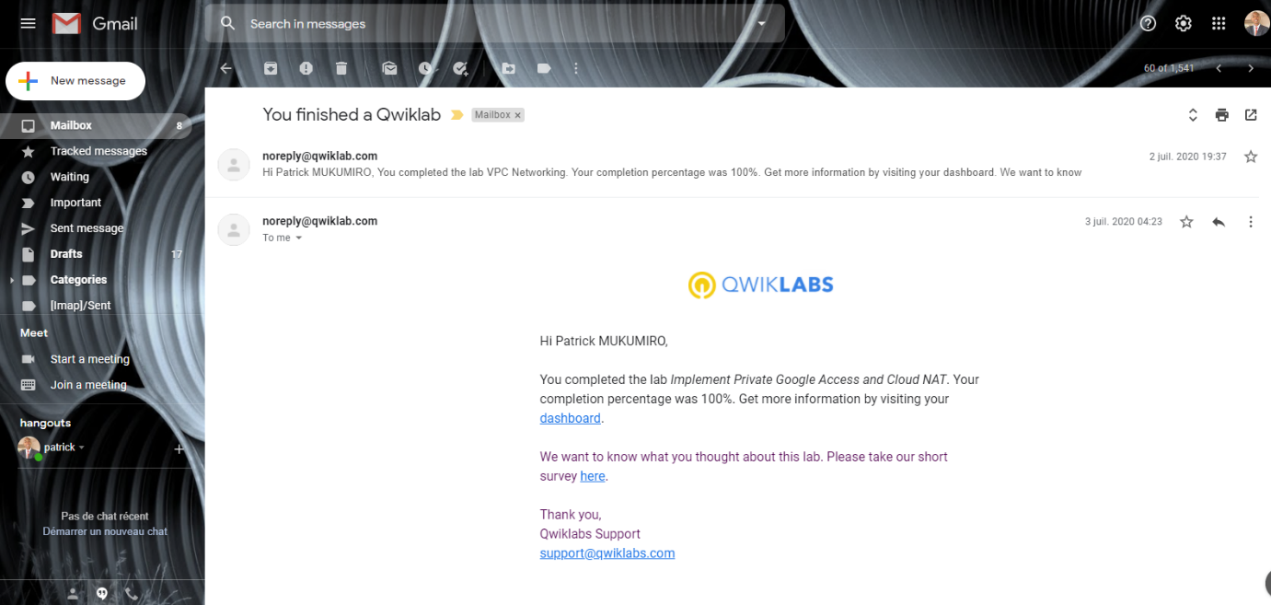

1. VPC Networking

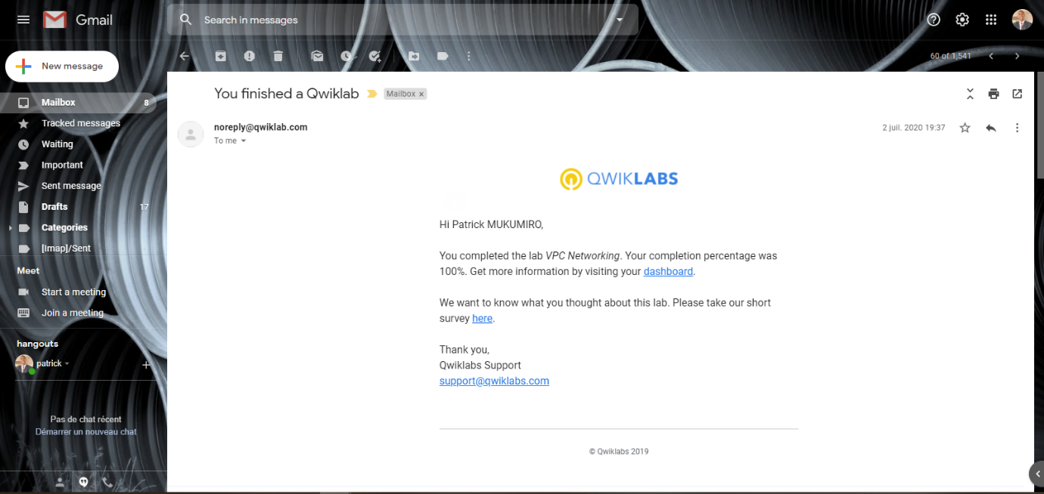

1. Infrastructure Preview

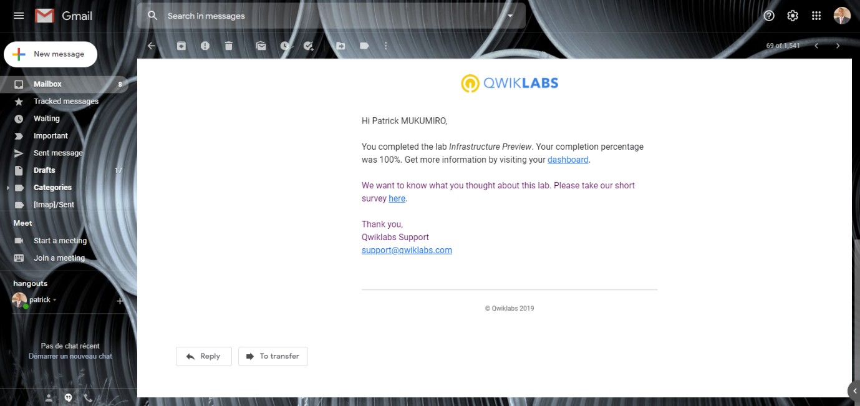

1. Console and Cloud Shell

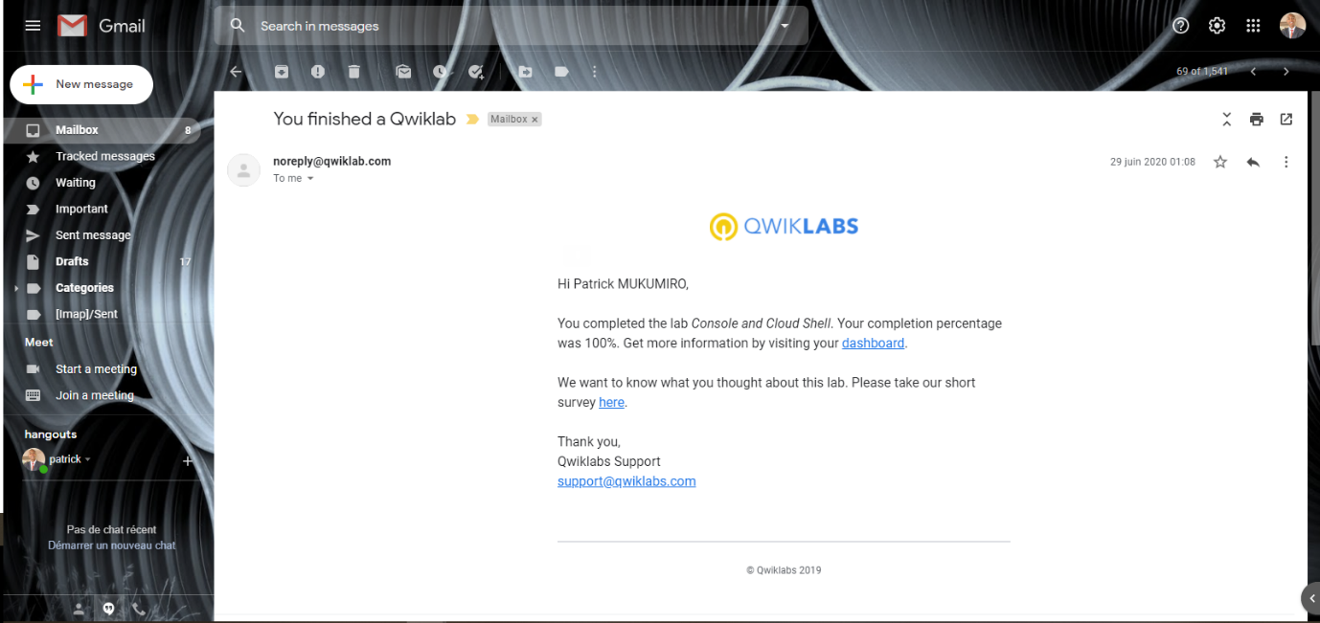

1. GCP Fundamentals: Getting Started with BigQuery

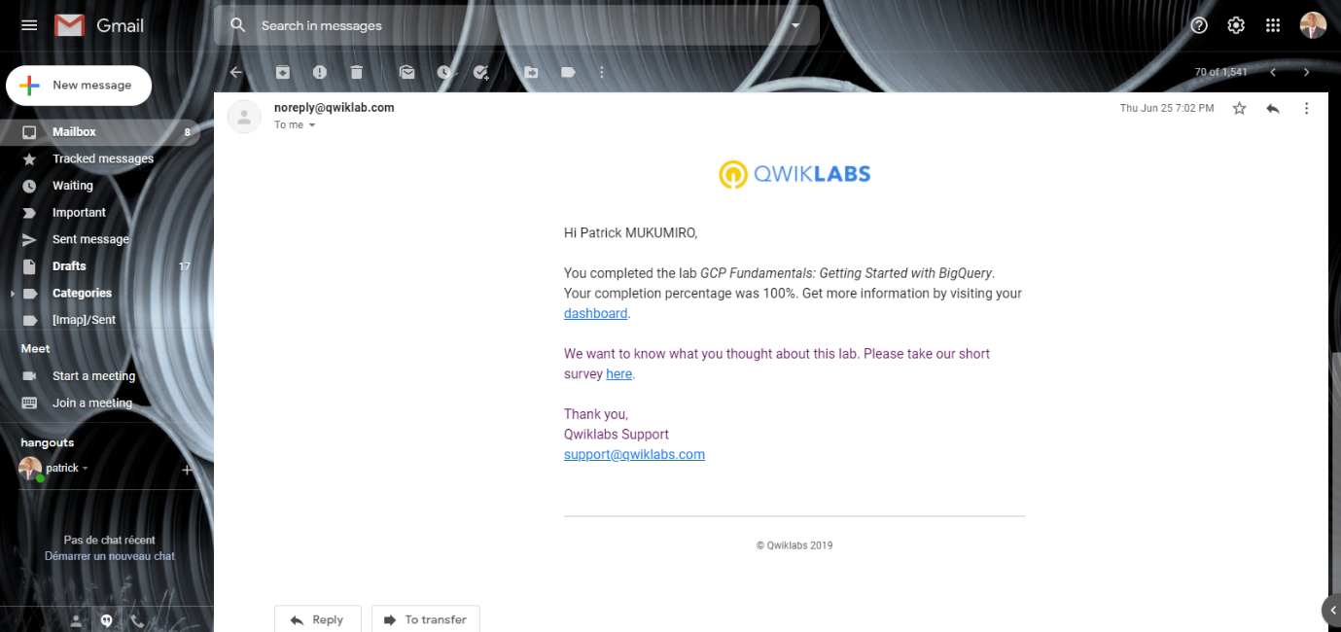

1. GCP Fundamentals: Getting Started with Deployment Manager and Stackdriver.

